As part of the Social, Personal and Health Education (S.P.H.E.) Programme we at St. Ibars N.S. encourage the children to become more aware of the need for healthy food in their lunch boxes. In addition, the Physical Education programme supports the physical development and fitness of the children. The Science curriculum also looks at the development of the body and deepens the children’s understanding of how the body grows and develops.

What people eat is known to be a key factor influencing health. Research indicates a strong link between diet and performance (e.g. a low sugar intake promotes concentration, lessens hyperactivity, protects teeth, and lessens the risk of diabetes. A low salt intake reduces the risk of heart disease in later life).

To promote healthy eating habits in our school, we introduced a new healthy eating policy starting from December 2018.

Aims:
- To promote the personal development and well-being of the child
- To promote the health of the child and provide a foundation for healthy living in all its aspects.

Objectives:
- To enable the child to appreciate the importance of good nutrition for growing and developing and staying healthy
- To enable the child to accept some personal responsibility for making wise food choices and adopting a healthy, balanced diet.

Lunch is an important meal for school going children. It should provide one third of their recommended daily allowance of nutrients without being high in fat, sugar or salt. It should also provide dietary fibre (roughage). In our school the children eat twice a day, before going out to play. To ensure good concentration it is important for children to drink lots of water, so please encourage your child to bring a bottle of water.

A word about Milk
Growing children should get approximately one pint of milk a day, or its equivalent as cheese, yoghurt or milk pudding. This ensures that they get enough calcium, which is essential for healthy bones and teeth.

The following guide is designed to help you provide quick, appetising, and nutritious lunches for your children:

Bread & Alternatives Savouries
Bread or rolls, preferably wholemeal Lean Meat
Rice – wholegrain Chicken/Turkey
Pasta – wholegrain Tinned Fish e.g. Tuna/sardines
Potato Salad Cheese
Wholemeal Scones Quiche
Bread sticks Pizza
Crackers
Pitta bread

Fruit & Vegetables Drinks
Apples, Banana, Peach Milk
Mandarins, Orange segments, Fruit juices
Fruit Salad, dried fruit, Squashes, i.e. low sugar
Plum, Pineapple cubes Yoghurt
Grapes,
Cucumber, Sweetcorn
Tomato,
Coleslaw.

What is a healthy lunch?
- It is full of goodness like protein, vitamins and calcium.
- Gives us strength and energy
- Makes us fit and healthy
- Helps our brain power

The Food Pyramid

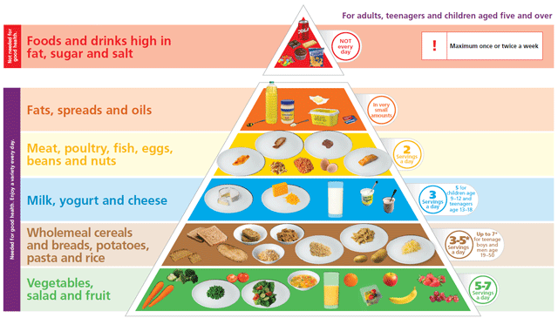

Sometimes it can be difficult to think of alternatives to these. Here are some tasty alternatives.
- Fruit (for example, an apple or banana, handful of grapes)
- Washed, raw vegetable pieces (for example, sticks of carrot, celery, pepper and cucumber.
- Half a tin of fruit (in its own juice)
- Plain breadsticks, unsalted plain or whole-wheat crackers, crispbreads or water biscuits served with fruit or cheese.
- Rice cakes
- Natural or low fat yogurt with fresh fruit (fresh, frozen or tinned in its own juice)
- Wholemeal or plain scones.
- Pasta or rice
- Cheese
- Hummus
- Olives

What is not recommended in a healthy lunch?
- Crisps
- Chocolate, sweets, lollipops or jellies
- Chewing gum
- Fizzy drinks

What drinks could we include in a healthy lunch?
- Water
- Milk
- Diluted Juices are only allowed at lunch times. These are not to be consumed throughout the day on a consistent basis as it has been shown that consistent drinking of these sugary drinks quickly brings on tooth decay.

What drinks are not recommended?
- Fizzy drinks
- Sugary drinks

Friday Treats
On Fridays children are permitted to bring One Fun-Sized treat along with their regular healthy lunch.

Who should make sure everyone follows the rules?
- Our parents, because they make our lunch and should set a good example. They are responsible for our health.
- We should, because it’s our health and we want to be fit and full of energy.
- Teachers, because they can see what’s in our lunch boxes and know who’s eating the right foods every day.
- The Principal

What should we do when children bring in foods that are not recommended?
- The children bring the food/drink home in their lunch box.

Should we make exceptions for special occasions?
- Yes, for treats after communion or confirmation
- Yes, for end of term parties
- Yes, for school trips (but in moderation in case we get sick on the bus)
- Yes, for class rewards

Green Flag School
Our green school motto is:
‘GET GREEN, KEEP GREEN, MAKE IT INTO A REGULAR ROUTINE!’

With this in mind, children are also asked to:
- take home (in lunchbox) all uneaten food, silver paper, wrappings, containers and cartons
- not bring in cans and glass – for safety reasons.

N.B. Parents/guardians of any child with a medical condition which requires a special diet should contact the school.

The children of St. Ibars N.S are very keen to have healthy lunches and show a good understanding of what that means. We hope these guidelines will assist everybody in making healthy choices.
Useful Information: The Health Promotion unit has a booklet called “Food and Nutrition Guidelines for Primary Schools”. It is available to download from www.healthpromotion.ie The Irish Nutrition and Dietetic Institute has a vast amount of information on nutrition and diet and have suggestions on what to include in school lunch-boxes. www.indi.ie

Roles and Responsibility:
- Parents/guardians have a responsibility to provide lunches which do not include any of the prohibited foods and, if possible, to include variety.
- Children have a responsibility to eat their own lunch, and not to share or trade food or drink with others
- Teachers have a responsibility to provide a good example through their own healthy eating habits
- The whole school community- staff, parents/guardians, children –will work together to promote the progress of this policy.
- The overall performance of the policy will be regularly monitored and evaluated by the BoM

Success Criteria:
We will know the policy is effective by:
- Observing what children have for lunch and noticing an improvement in consumption of fruit, vegetables and other healthy foods.

Timeframe for Implementation: 2019/2020

Timeframe for review: November 2021.

Ratification and Communication:

The BoM ratified the policy at its meeting on 19/11/2018 after it had been drafted, circulated and amended. The policy has been communicated to all staff and children, and has been downloaded on to the school website. It will be promoted in the school as part of the SPHE policy and its importance will be stressed in newsletters.

Signed: Eugene Byrne Date:19/11/2018

_____________________
(Chairperson Board of Management)

